PARKCREST CHILDREN’S CENTRE
REGISTRATION FORM FOR CHILD CARE

E-mail (Gmail preferred) | How did you hear about us?
FULL NAME OF CHILD (used for documents, artwork and nametags) | USUAL NAME OF CHILD (if different)
Required information
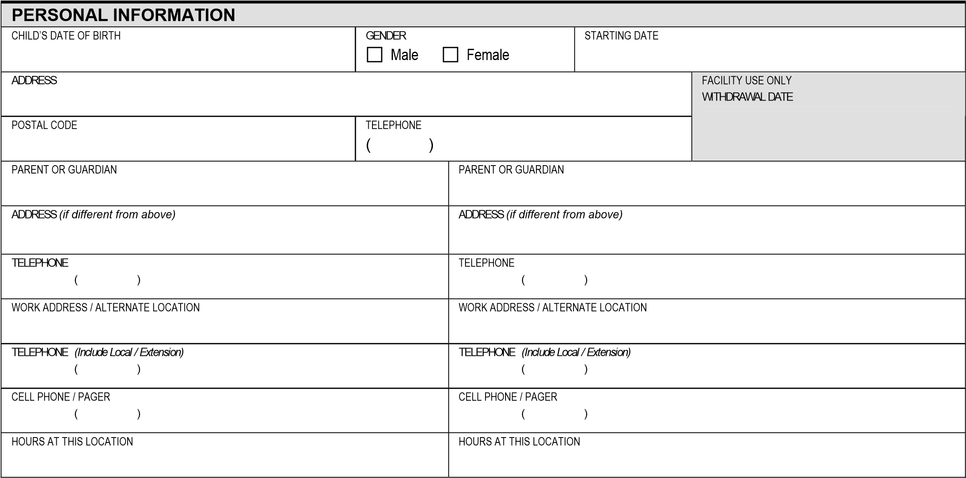
EMERGENCY HEALTH INFORMATION |  | Required for registration
CARE CARD NUMBER
FAMILY DOCTOR / CLINIC NAME |  | DOCTOR / CLINIC TELEPHONE
CONSENT FOR EMERGENCY CARE
I authorize the staff at the child care centre to call a medical practitioner or ambulance / transport child to emergency medical care, in the case of accident or illness of my child(ren), if the parent cannot immediately be reached. |  |  |  | Yes |  |  | No
ALTERNATE PERSONS(S) AUTHORIZED TO PICK UP CHILD (other than parent/guardian listed above, include emergency pickup)
Check all that apply
Name | Relationship |  | Telephone |  | Authorized to Pickup | Authorized to  Call in an  Emergency

PERSONS(S) WHO ARE NOT PERMITTED ACCESS TO MY CHILD
Name | Relationship | Telephone

CUSTODY OR OTHER LEGAL ORDERS
- Yes  - No | If yes, supply a copy of the order to the facility Manager / Licensee

CHILD’S IMMUNIZATION STATUS
Is your child up to date on immunizations? | Yes | No | Not Immunized

HEALTH INFORMATION (attach a separate sheet, if necessary)
REGULAR MEDICATION(S) AND REASONS FOR (please list)
ALLERGIES AND TREATMENT (please list)
INJURY(S), ILLNESS(ES) OR OPERATIONS YOUR CHILD HAS HAD AND INCLUDE DATE(S)
- Please describe any concern(s) / issues regarding your child’s health (seizures, asthma, vision, hearing, etc).
- Please describe any concerns you may have regarding your child’s development (i.e. behaviour, vision, hearing, speech, language, mobility, etc.)
- Describe any specific care instruction regarding 1) and/or 2) above.
- Dietary Restrictions:
OTHER HEALTH CARE PROFESSIONALS

Supported Child Development at BC Centre For Ability
Yes € No €

Fraser Health Speech Therapy
Yes € No €

Sunny Hill or Monarch House
Yes € No €

Behaviour Consultant or Interventionist
Yes € No €

Due to our limited capacity, registration wait times may vary for children who are waiting for intake, assessments or require additional support and services.

PARENT CONCERNS SURROUNDING DEVELOPMENT (AUTISM, SPEECH, HEARING, ANXIETY, ATTENTION)

SIGNATURE OF PARENT OR GUARDIAN PROVIDING INFORMATION
SIGNATURE | PRINT NAME | DATE

NOTE: This information may be reviewed by Fraser Health Authority Licensing staff as per legislation.

ADDITIONAL INFORMATION ABOUT YOUR CHILD
GROUP EXPERIENCES
WHAT IS/ARE YOUR CHILD’S FAVOURITE TOY(S) / ACTIVITIES
HAS YOUR CHILD HAD PREVIOUS PLAY GROUP EXPERIENCE?
Yes No _{IF YES, HOW DID HE/SHE ADAPT?}
HOW DOES YOUR CHILD BEHAVE TOWARD OTHER CHILDREN? (E.G. SEEKS OTHERS OUT, FEELS SHY)
EMOTIONAL
HOW DOES YOUR CHILD REACT WHEN LEFT WITH UNFAMILIAR PEOPLE AND/OR IN UNFAMILIAR SITUATIONS?
DOES YOUR CHILD HAVE ANY PARTICULAR FEARS? PLEASE DESCRIBE.
WHAT SUGGESTIONS DO YOU HAVE THAT WOULD HELP STAFF MAKE YOUR CHILD’S TRANSITION INTO THIS PROGRAM EASIER?
FAMILY AND GENERAL HOUSEHOLD INFORMATION
PLEASE LIST THE NAMES OF THE SIGNIFICANT PEOPLE IN YOUR CHILD’S LIFE (E.G. SIBLINGS, GRANDPARENTS, ETC)
PLEASE DESCIBE THE GUIDANCE AND DISCIPLINE METHODS USED AT HOME.
PRIMARY LANGUAGE SPOKEN IN THE HOME |  | OTHER LANGUAGES
NAME OF ENGLISH SPEAKING PERSON (IFF NEEDED) |  | TELEPHONE
EATING AND NUTRITION
LIST YOUR CHILD’S FAVOURITE FOOD
LIST ANY DISLIKED FOOD.
PLEASE DESCIBE ANY PARTICULAR EATING PATTERNS.
ARE THERE ANY RELIGIOUS OR ETHNIC OBSERVANCES RELATED TO FOODS?
SLEEPING
NAP TIME | HOW LONG TO SETTLE |  | TIME OF WAKING
BEDTIME | HOW LONG TO SETTLE |  | TIME OF WAKING
DOES YOUR CHILD TAKE A FAVOURITE COMFORTER (E.G. BLANKET OR TOY) TO BED?
Yes No IF YES, DESCRIBE AND TELL US IF IT IS “NAMED”.
TOILETING IS YOUR CHILD TOILET TRAINED?  Yes No PARTIALLY |  |  | PLEASE INDICATE YOUR CHILD’S FREQUENCY OR PATTERNS FOR BOWEL MOVEMENTS.
DESCRIBE ASSISTANCE NEEDED FOR TOILETING. |  |  | WHAT “SPECIAL” WORD DOES YOUR CHILD USE FOR?  URINATION: BOWEL MOVEMENTS:

PERMISSION FOR OUTINGS
I hereby give my permission to the Parkcrest Children’s Centre to take my child:
____________________________ on outings within walking distance of the center. I understand that my child will NOT be taken on outings requiring the use of a personal vehicle or public transit without my prior and specific written consent, except in cases of emergency.
Signature of Parent or Guardian:____________________________________ Date:________________

PERMISSION FOR PICTURE TAKING
I hereby give permission to the care providers of Parkcrest Children’s Centre to take pictures of my child: _______________________ for documentation within the center.
Throughout the preschool year we will be taking photos to document the children’s experiences. If you would like to receive photos of the classroom experiences please indicate by circling one below.

YES, I would like to receive e-mails. NO, I would not like to receive e-mails.

Signature of Parent or Guardian:____________________________________ Date:________________
Please print your e-mail address clearly.
E-mail:___________________________________________

PERMISSION FOR EMERGENCY MEDICAL AID IN CASE OF ACCIDENT OF INJURY
I hereby give my permission to the care provider of Parkcrest Children’s Centre to call a physician or ambulance in the case of accident or illness of my child: __________________________when I cannot be immediately reached.

Signature of Parent of Guardian: ___________________________________ Date: ________________

Parkcrest Preschool Parent Agreement

Child’s Name: ______________________________________

- I have read the parent booklet in detail and agree to follow Parkcrest Preschool policies and procedures.

- I agree to keep an open line of communication with the preschool and share any concerns or information regarding my child. This includes, and is not limited to organizations that my child is involved with such as Supported Child Development, BC Centre for Ability, Fraser Health, Infant Development, Sunny Hill, and other health professionals. I understand that I may be placed on a waitlist until the preschool Director has met my child to determine if the preschool can meet my child’s needs.

- I will make every effort to be on time when dropping off and picking up my child/children. I understand that if I am consistently late in picking up my child, I will be charged a late fee. If this continues, the Children’s Centre Board may require to withdraw my child from the preschool.

- I will not send my child to school if there is any question of illness. If any child contracts a communicable disease, I will
notify the preschool immediately. I will also advise the teacher of any allergies or dietary concerns.
- I am aware that if my child is unable to attend pre-school due to illness or holidays, that I am still responsible for full payment of fees.
- I agree to give Parkcrest Preschool one month’s notice in writing to withdraw my child. Notice must be given prior to, or on the first of the month to receive eligible refunds. I am liable for one month’s payment of fees in lieu of notice. I understand that June’s fee can only be refunded if my child is withdrawn prior to May 1st (Notice given prior to April 1st).

- I agree to pay my child’s fees on the first of every month using the Pre Authorized Payment Plan, with the first month’s fees to include June’s fees.
- I will notify the teacher of any unusual circumstances at home which may affect my child’s behavior at preschool.

- I agree to provide a nutritious peanut/tree nut free lunch for my child each day.

- I understand that my child will not be dismissed to ANYONE other than persons who have been made known to the teachers previously.

- I agree to keep the preschool informed of current changes in address, phone number, or any other emergency information.

- In case of injury to my child while in the care, custody or control of the Parkcrest Children’s Centre, I hereby waive all claims against the Children’s Centre in excess of public liability insurance carried by Parkcrest Children’s Centre. In case of an emergency my child will be taken by ambulance to the nearest hospital and attended to by the physician on duty.

- In case of car-pooling and transportation of children other than my own, to and from the preschool, I am aware that at least $2,000,000 third party liability on my private vehicle is required.

- I understand that my child may have to be withdrawn from the Centre if the safety of my child and the other children is in jeopardy. No notice is required from the Centre for withdrawal and the remainder of the tuition fees will be refunded.

_____________________________________________ ________________________

Signature of Parent or Guardian Date

